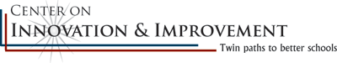
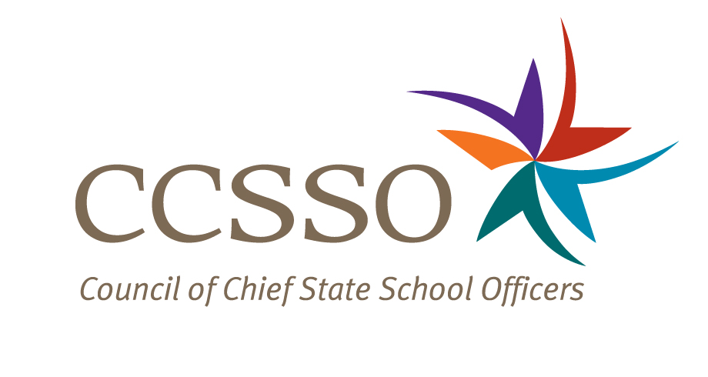

National Network of State School Improvement Leaders
Webinar – Meeting the Needs of English Language Learners (ELLs) through School Improvement

Attendee Online Registration*: https://ccsso.webex.com/ccsso/onstage/g.php?t=a&d=713777954
Call-in toll-free number (US/Canada)*: 866-469-3239
Event Number: 713 777 954
Start Time: 3:00 PM ET/2:00 CT/1:00 MT/12:00 PT

* Notice for Participants & Panelists: Please login first before calling. When signing on online, please use your state abbreviation or organization’s acronym before typing your name.
(ex: MA-Horace Mann)

Agenda

Objectives
Introduce the WebEx format & the day’s webinar session and presenters
Present a reflective framework to increase internal dialogue and integration of program supports for English language learners(ELLs)
Present perspectives from Illinois and a charter school co-op in Colorado
Discuss questions raised by attendees

Tuesday, August 28, 2012
3:00-3:06 | WebEx Orientation and Introductions (Nina de las Alas and Tom Kerins)  Go to www.centerii.org/leaders for complete descriptions of the Network, today’s webinar and presenters’ biographies.
3:06-3:16 | Building Internal Coherence in Supports (Jayne Sowers, Lead for Indiana, Great Lakes East Comprehensive Center)  - Introduce a reflective framework to assist SEA and LEA staff to increase internal dialogue and integration of program supports for ELLs
3:16-3:26 | Illinois (Reyna Hernandez, Assistant Superintendent in the Center for Language and Early Child Development)  - How is the Illinois State Board of Education identifying and differentiating the ELLs in schools and districts in the state?  - What strategies and supports are they providing to increase the linguistic and content understanding of ELLs?  - How are they measuring the ELLs' progress?  - How are they determining the agency’s progress toward meeting the needs of ELLs?  - What are the challenges and successes, particularly with the economic “New Normal”?
3:26-3:46 | Hope Online Learning Academy Co-Op (Janet Filbin, Director of Student Achievement, Hope Online Learning Academy Co-Op, Centennial, Colorado)  - How is Colorado identifying and differentiating the ELLs in schools and districts in the state? How is Hope Online Learning identifying and differentiating ELLs?  - What strategies and supports is the state agency providing to increase the linguistic and content understanding of ELLs? What is Hope Online Learning providing to increase the linguistic and content understanding of ELLs?  - How are they measuring the ELLs' progress?  - How are they determining Hope Online Learning’s progress toward meeting the needs of ELLs?  - What are the challenges and successes, particularly with the economic “New Normal”?
3:46-3:55 | Q & A from attendees  [Please type in your questions in Q & A section of WebEx or use the raise-your–hand icon].
3:55- 4:00 | Housekeeping (Nina de las Alas)  - Recording of Session, PPT slides, and additional resources  - Reminder: Feedback and Registration for September 18 webinar  - Questions? Send to Nina de las Alas, ninaa@ccsso.org
4:00 | Adjourn

