
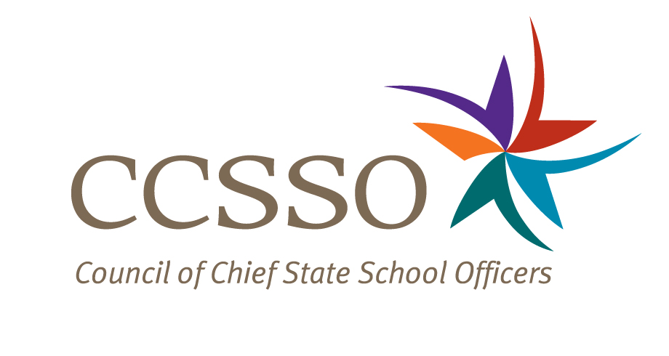

National Network of State School Improvement Leaders
Webinar – Addressing the Needs of All Students through School Improvement

Attendee Online Registration*: https://ccsso.webex.com/ccsso/onstage/g.php?t=a&d=712822535
Call-in toll-free number (US/Canada)*: 866-469-3239
Event Number: 712 822 535
Start Time: 3:00 PM ET/2:00 CT/1:00 MT/12:00 PT

* Notice for Participants & Panelists: Please login first before calling. When signing on online, please use your state abbreviation or organization’s acronym before typing your name.
(ex: MA-Horace Mann)

Agenda

Objectives
Introduce the WebEx format & the day’s webinar session and presenters
Present perspectives from North Carolina and Idaho
Discuss questions raised by attendees

Tuesday, September 18, 2012
3:00-3:08 | WebEx Orientation and Introductions (Nina de las Alas and Susan Hanes)  Go to www.centerii.org/leaders for complete descriptions of the Network, today’s webinar and presenters’ biographies.
3:08-3:24 | North Carolina (George Hancock and Sherry Thomas, North Carolina Department of Public Instruction)  - How is the SEA orchestrating and integrating various state and federal programs, policies, practices and intervention strategies that address different student groups to meet the needs of all students?  - What strategies and supports is the SEA providing to districts, schools and communities to improve the outcomes of all its students?  - How is the SEA determining progress for its own agency as well as for districts, schools and students?  - What are the specific challenges that the SEA is facing as they help LEAs address the needs of particular student subgroups such as economically disadvantaged students, students with disabilities (SWDs), and students of major racial, ethnic and linguistic groups?  - What are the successes?
3:24-3:40 | Idaho (Steve Underwood, Idaho State Department of Education)  - How is the SEA orchestrating and integrating various state and federal programs, policies, practices and intervention strategies that address different student groups to meet the needs of all students?  - What strategies and supports is the SEA providing to districts, schools and communities to improve the outcomes of all its students?  - How is the SEA determining progress for its own agency as well as for districts, schools and students?  - What are the specific challenges that the SEA is facing as they help LEAs address the needs of particular student subgroups such as economically disadvantaged students, students with disabilities (SWDs), and students of major racial, ethnic and linguistic groups?  - What are the successes?
3:40-3:55 | Q & A from attendees  [Please type in your questions in Q & A section of WebEx or use the raise-your–hand icon].
3:55- 4:00 | Housekeeping (Nina de las Alas)  - Recording of Session, PPT slides, and additional resources  - Reminder: Feedback and Follow-Up Session  - Questions? Send to Susan Hanes, smhanes17@comcast.net  - .
4:00 | Adjourn

