Summary of garbled audio during the Q & A discussion—Meeting the Needs of English Language Learners (ELLs) through School Improvement, Tues., August 28, 2012
Time stamp: 47:29 through 51:19
[Audio problems begin]
Tom Kerins (CII and moderator) complimented Jayne Sowers’ (Great Lakes East Comprehensive Center) presentation and noted that it is similar to the work that he and Susan Hanes have done with the Evaluating and Improving the SEA System of Recognition, Accountability and Support, which has recently been updated and is now available at http://www.centerii.org/survey. A link to the resource is also available on the NNSSIL website—http://www.centerii.org/leaders. The document also includes ESEA flexibility waiver requirements.
Tom then had a follow-up question for Reyna Hernandez (ISBE) regarding slide # 3 which shows ELL participation rates. He asked: Why is the ELL participation rate in high school and middle school so much lower than in elementary school?
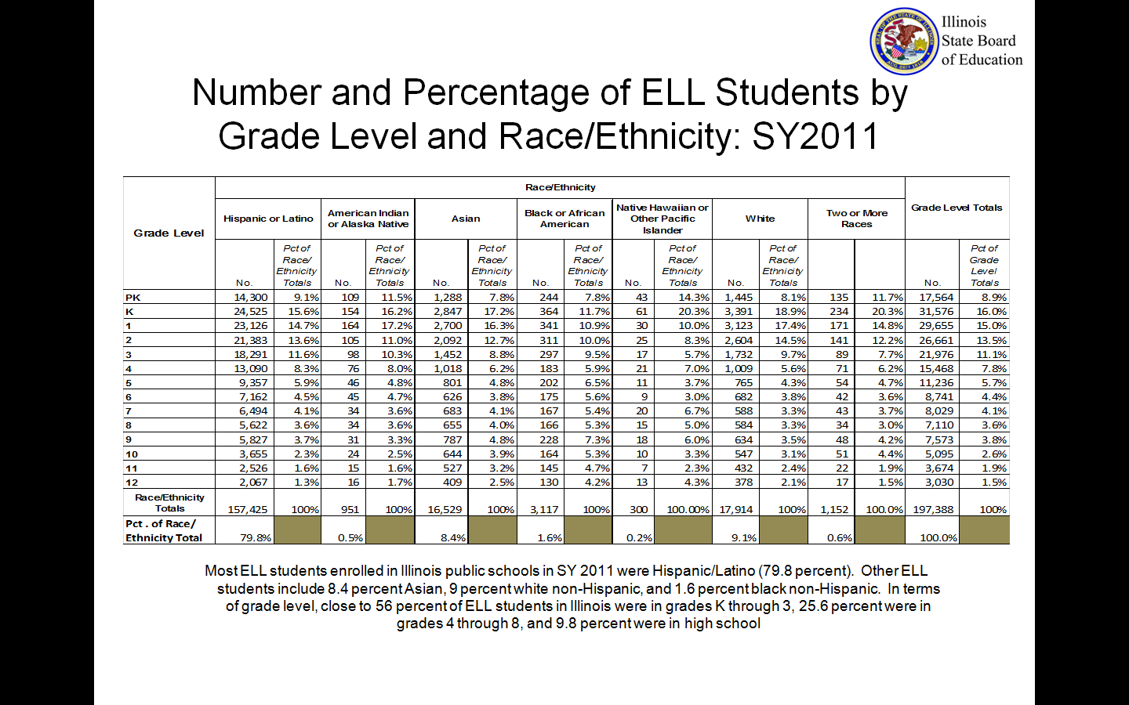
Reyna responded that in Illinois they do allow for development English language instruction where students are learning multiple languages simultaneously. However the baseline program is a transitional program in which students receive at least three years of ELL instruction and then they exit the program once they are proficient in English. Most of the children enter the program when they are very young, and therefore exit during their elementary school years. Those older children who enter high school are mostly newcomers, and they have a very different way of learning. The state does have long-term ELLs who do not become proficient. This phenomenon generally raises a red flag for additional assessments and supports for those children.
Tom then began with questions submitted in advance, starting with two questions from Idaho’s Steve Underwood:
• In what ways is each presenter involved in the general school and/or improvement planning requirements required for ESEA (and now the waiver)?
• In the school and/or district improvement planning that they do, how do they go about developing an improvement plan that is both system-wide, representing all students, as well as specific enough to address ELs?
[Audio problems resolved]

